S70FL01GSAGMFI011 flash memory SPI Buses interface with microcontroller,width=0.2mm
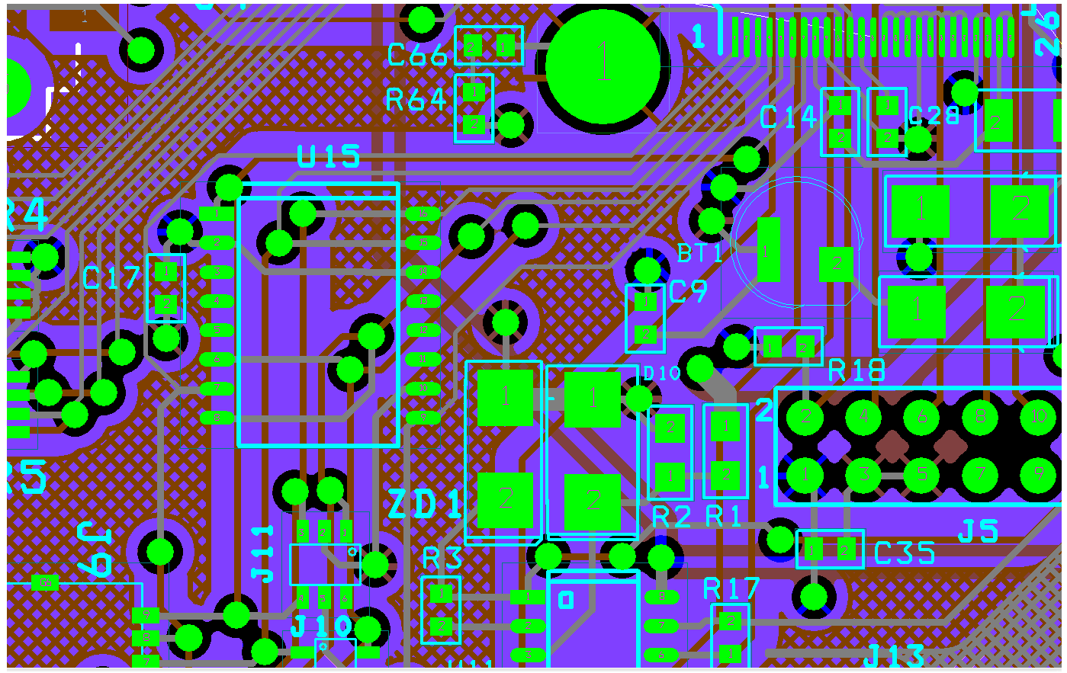
Ground plane- 2nd layer.
Power plane -3rd layer.

S70FL01GSAGMFI011 flash memory on located on top side of PCB

