CCG programming in PSoC Creator

Starting with a CYPD4225…

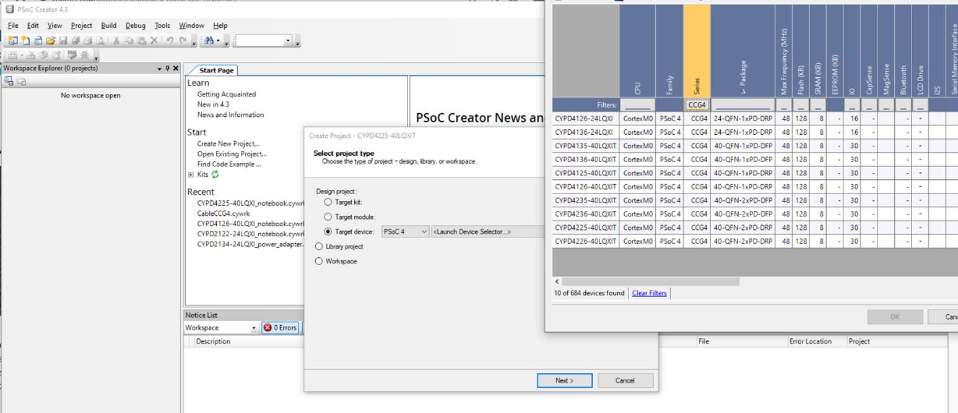

Then select the CYPD4225 notebook example

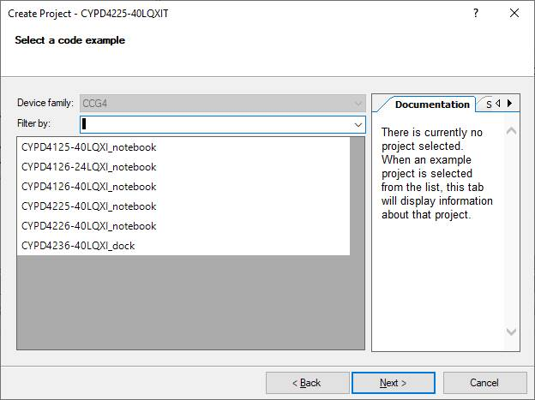

I’ve been truncating the workspace and project name by removing the “01”. There may be a batch file that’s looking for the file name without the extra numbers.

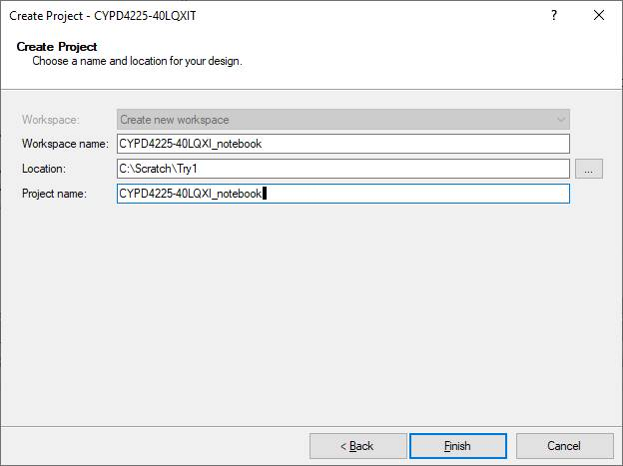

I do get initial errors then do a component update

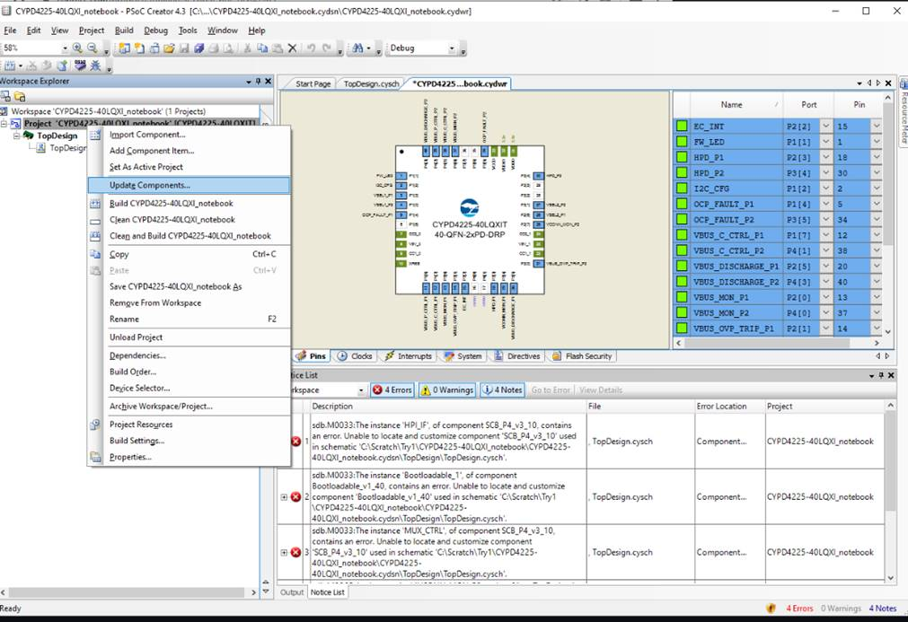

I’m still getting a error after running a clean and build.

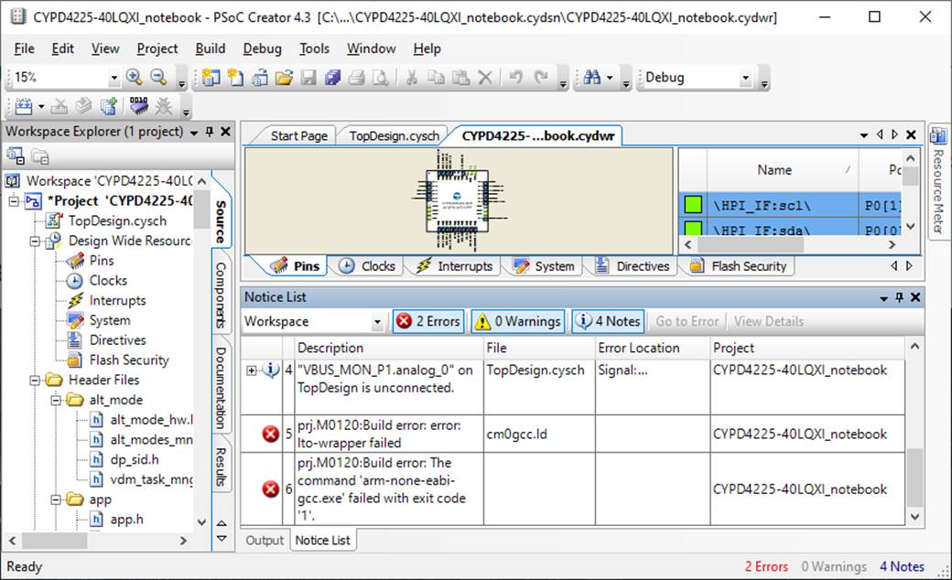

I can’t get past this last failure of lto-wrapper failed.

Reference Community Post

* What is required for PSoC Creator 4.x to support CCG parts? @ [https://community.cypress.com/thread/53395](https://nam04.safelinks.protection.outlook.com/?url=https%3A%2F%2Fcommunity.cypress.com%2Fthread%2F53395&data=02%7C01%7Cgcarson%40arrow.com%7Ca80f659fa2b5409274b208d7d66f2945%7C0beb0c359cbb4feb99e5589e415c7944%7C1%7C0%7C637213645286108798&sdata=S3%2B6rZXwgHpW4RMrj7b5H0jlaa%2FfMXZKxcAnTjDYxo8%3D&reserved=0)

Attempting to run examples for CCG4 components results in linker failures.

Advice on community has been to use PSoC Creator 3.x.

When will a fix for these issues be available?

Reference:

* "lto-wrapper failed" Error when compiling CCG4 eval board firmware on PSoc 4.2 @ [https://community.cypress.com/message/193060](https://nam04.safelinks.protection.outlook.com/?url=https%3A%2F%2Fcommunity.cypress.com%2Fmessage%2F193060%23193060&data=02%7C01%7Cgcarson%40arrow.com%7Ca80f659fa2b5409274b208d7d66f2945%7C0beb0c359cbb4feb99e5589e415c7944%7C1%7C0%7C637213645286108798&sdata=8AK%2FmbK398aeWbq6D8Se0f9CarUFAHEISJcy8p48XtQ%3D&reserved=0)
* How to resolve the build error "lto_wrapper failed" in PSoc Creator 4.2? @ [https://community.cypress.com/message/159325](https://nam04.safelinks.protection.outlook.com/?url=https%3A%2F%2Fcommunity.cypress.com%2Fmessage%2F159325%23159325&data=02%7C01%7Cgcarson%40arrow.com%7Ca80f659fa2b5409274b208d7d66f2945%7C0beb0c359cbb4feb99e5589e415c7944%7C1%7C0%7C637213645286118795&sdata=XgK%2FC9wHL3oQPAjFqPpX2pbQkZ5FSp26%2BECl7y28fSU%3D&reserved=0)
* Compile error with Creator 4.1 @ [https://community.cypress.com/message/184795](https://nam04.safelinks.protection.outlook.com/?url=https%3A%2F%2Fcommunity.cypress.com%2Fmessage%2F184795%23184795&data=02%7C01%7Cgcarson%40arrow.com%7Ca80f659fa2b5409274b208d7d66f2945%7C0beb0c359cbb4feb99e5589e415c7944%7C1%7C0%7C637213645286118795&sdata=G%2FMQnNY4I%2F9kRGbNgjTquJ8ioRwz7XrSBkCzT9npgLs%3D&reserved=0)

=================================

Environment from PSoC Creatory Help/About

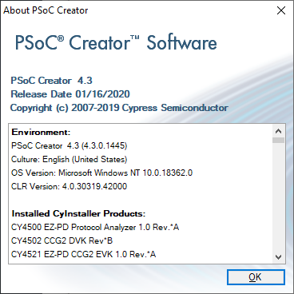

Full list from above window:

**Environment:**

PSoC Creator 4.3 (4.3.0.1445)

Culture: English (United States)

OS Version: Microsoft Windows NT 10.0.18362.0

CLR Version: 4.0.30319.42000

**Installed CyInstaller Products:**

CY4500 EZ-PD Protocol Analyzer 1.0 Rev.*A

CY4502 CCG2 DVK Rev*B

CY4521 EZ-PD CCG2 EVK 1.0 Rev.*A

CY4531 EZ-PD CCG3 EVK 1.0 Rev.*A

CY4532 EZ-PD CCG3PA EVK Rev.*A

CY4541 EZ-PD CCG4 EVK 1.0 Rev.*A

CY8CKIT-017 CAN-LIN EBK 2.1 Rev*B

CY8CKIT-026 CAN and LIN SHIELD KIT Rev**

CY8CKIT-041-40XX PSoC 4 S-Series Pioneer Kit 1.0 Rev.*B

CY8CKIT-042 PSoC 4 Pioneer Kit 1.0 Rev.*E

CY8CKIT-042-BLE-A Kit 1.0 Rev.*B

CY8CKIT-043 PSoC 4 M-Series Prototyping Kit 1.0 Rev.**

CY8CKIT-044 PSoC 4 M-Series Pioneer Kit 1.0 Rev.*C

CY8CKIT-046 PSoC 4 L-Series Pioneer Kit 1.0 Rev.*A

CY8CKIT-049-41xx PSoC 4 Prototyping Kit 1.0 Rev.*A

CY8CKIT-049-42xx PSoC 4 Prototyping Kit 1.0 Rev.*A

CY8CKIT-059 PSoC 5LP Prototyping Kit 1.0 Rev.*A

CY8CKIT-062-BLE PSoC 6 BLE Pioneer Kit 1.0 Rev.*E

CY8CKIT-062-WiFi-BT PSoC 6 WiFi-BT Pioneer Kit 1.0 Rev.**

CY8CKIT-145-40XX PSoC 4000S Prototyping Kit 1.0 Rev.*A

CY8CKIT-148 PSoC 4700S Inductive Sensing Evaluation Kit 1.0 Rev.*B

CY8CKIT-149 PSoC 4100S Plus Prototyping Kit 1.0 Rev.**

CYALKIT-E02 Solar-Powered BLE Sensor Beacon RDK 1.0 Rev.*B

Cypress Document Manager 1.0 SP1

Cypress BLE-Beacon 1.2

CySmart 1.3

CYUSBS232 RDK 1.0 Rev*B

CYUSBS236 DVK 1.0 Rev*A

EZ-PD CCGx Host SDK 3.3

EZ-PD CCGx Power SDK 3.3

EZ-PD CCGx SDK 3.0.2

EZ-PD Configuration Utility 1.1

EZ-PD DOCK REFERENCE DESIGN 1.1

EZ-USB FX3 SDK 1.3.4

HX3 Blaster Plus V1.0

Peripheral Driver Library 2.1.0

Peripheral Driver Library 3.0.1

Peripheral Driver Library 3.0.3

Peripheral Driver Library 3.0.4

Peripheral Driver Library 3.1.0

Peripheral Driver Library 3.1.1

Peripheral Driver Library 3.1.2

PSoC Programmer 3.28.6

PSoC 3 Development Kit Rev*D

PSoC 5LP Development Kit Rev*F

PSoC Creator 4.2

PSoC Creator 4.3

PSoC Designer 5.4 SP1

SuperSpeed Explorer Kit Rev**

USB-Serial SDK 2.0

**Loaded Plugins:**

Name: Customizer Loader

Version: 4.3.0.1445

Company: Cypress Semiconductor

Description: Loads component customizers.

Name: Addin Discovery

Version: 4.3.0.1445

Company: Cypress Semiconductor

Description: Discovers PSoC Creator addins (kits, language packs, etc)

Name: Device Catalog

Version: 4.3.0.1445

Company: Cypress Semiconductor

Description: Device Catalog Plugin

Name: Documentation

Version: 4.3.0.1445

Company: Cypress Semiconductor

Description: Adds the topics available in the documentation.

Name: Start Page

Version: 4.3.0.1445

Company: Cypress Semiconductor

Description: Adds a start page to the framework.

Name: Output Window Plugin

Version: 4.3.0.1445

Company: Cypress Semiconductor

Description: Adds the output window

Name: SCC Manager

Version: 4.3.0.1445

Company: Cypress Semiconductor

Description: The Source Code Control Manager is the central class used for SCC actions within PSoC Creator.

Name: Symbol, Schematic and SchMacro Factory

Version: 4.3.0.1445

Company: Cypress Semiconductor

Description: The Symbol and Schematic Factory is used to load, cache, and retrieve symbols and schematics.

Name: Project Manager Plugin

Version: 4.3.0.1445

Company: Cypress Semiconductor

Description: Adds project management related functionality.

Name: GDE Plugin

Version: 4.3.0.1445

Company: Cypress Semiconductor

Description: Loads the Symbol and Schematic editors

Name: Language Plugin

Version: 4.3.0.1445

Company: Cypress Semiconductor

Description: Supports user files in multiple languages

Name: Workspace Factory

Version: 4.3.0.1445

Company: Cypress Semiconductor

Description: The Workspace Factory is used to retrieve instances of PSoC Creator workspaces.

Name: Project Factory

Version: 4.3.0.1445

Company: Cypress Semiconductor

Description: The Project Factory is used to retrieve instances of PSoC Creator projects.

Name: Toolchain Manager

Version: 4.3.0.1445

Company: Cypress Semiconductor

Description: PSoC Creator Toolchain Manager

Name: ARM GCC Generic

Version: 4.3.0.1445

Company: Cypress Semiconductor

Description: ARM GNU Generic

Name: ARM MDK Generic

Version: 4.3.0.1445

Company: Cypress Semiconductor

Description: ARM MDK Generic

Name: ARM IAR Generic

Version: 4.3.0.1445

Company: Cypress Semiconductor

Description: ARM IAR Generic

Name: DP8051 Keil Generic

Version: 4.3.0.1445

Company: Cypress Semiconductor

Description: DP8051 Keil Generic

Name: Device Selector

Version: 4.3.0.1445

Company: Cypress Semiconductor

Description: Adds a dialog that allows the user to select a device.

Name: File Editor Factory Plugin

Version: 4.3.0.1445

Company: Cypress Semiconductor

Description: Add file editors to the framework.

Name: Transport Framework

Version: 4.3.0.1445

Company: Cypress Semiconductor

Description: Provides a generic device communication framework for use by other plugins.

Name: Debugger Core

Version: 4.3.0.1445

Company: Cypress Semiconductor

Description: The Core Debugger provides an architecture independent framework for the common debug features.

Name: PSoC Debugger

Version: 4.3.0.1445

Company: Cypress Semiconductor

Description: Provides debugging support for the different PSoC families through a GDB back end.

Name: FM Debugger

Version: 4.3.0.1445

Company: Cypress Semiconductor

Description: Provides debugging support for FM device families

Name: Device IO Transport

Version: 4.3.0.1445

Company: Cypress Semiconductor

Description: Provides device IO support for Cypress devices though PSoC Programmer APIs.

Name: Serial Transport

Version: 4.3.0.1445

Company: Cypress Semiconductor

Description: Provides basic serial device support for the rest of the tool.

Name: Bootloader Host

Version: 4.3.0.1445

Company: Cypress Semiconductor

Description: Provides a host tool to perform bootloading operations.

Name: Background Elaborator

Version: 4.3.0.1445

Company: Cypress Semiconductor

Description: PSoC Creator Background Elaborator.

Name: TypeCache Factory

Version: 4.3.0.1445

Company: Cypress Semiconductor

Description: The TypeCache Factory is used to retrieve instances of TypeCaches.

Name: PSoC Fitter

Version: 4.3.0.1445

Company: Cypress Semiconductor

Description: PSoC Fitter Plugin

Name: FM Fitter

Version: 4.3.0.1445

Company: Cypress Semiconductor

Description: FM Fitter Plugin

Name: DWR Plugin

Version: 4.3.0.1445

Company: Cypress Semiconductor

Description: Registers resource editors with devices.

Name: DMA Wizard

Version: 4.3.0.1445

Company: Cypress Semiconductor

Description: Enables quick and correct development of applications that use DMA.

Name: Tuner Plugin

Version: 4.3.0.1445

Company: Cypress Semiconductor

Description: Manages custom component tuner executables

Name: Notice Window

Version: 4.3.0.1445

Company: Cypress Semiconductor

Description: The Notice Window displays notices (status messages / errors with managed lifetimes).